ENGR 850: Digital Design Verification

Final Exam

Allowed time: take home

Name:

I certify that I did not copy the answers to this exam and did not let anyone copy my answers (Initials): ______

Consider the following module describing an accumulator:

module accumulator (
output reg [15:0] sum, // accumulated out
input [7:0] in, // input
input rst, clk ); // reset and clock inputs
wire carry;
wire [15:0] sum_in;
assign {carry,sum_in} = sum + in;
always@(posedge clk)
if (rst) sum <= 0; else
sum <= (carry)? 16'hFFFF : sum_in;
endmodule

As you can see from the design code, it has the following specifications:
- An active high reset (rst) that is synchronous to the positive edge of the clock (clk) and clears the output (sum) to zero
- Once reset is removed, the accumulator accumulates summation of the data present on the data input (data) on every positive clock edge and if the summation exceeds the maximum value that can be represented using a 16-bit number (i.e. 16’hFFFF), the output gets saturated at 16’hFFFF
- The design treats the input data as an unsigned number and produces the output also as unsigned value.

The following is the top level testbench for this design. It contains a clock generator, an instance of the interface (ac_if), the test program (test), and the design under test (accumulator).

`timescale 1ns/1ps

module top;

bit clk;
parameter clk_per=10; //clock period
always #(clk_per/2) clk = ~ clk; //clock generation

ac_if acif(clk); //Interface
test tst(acif); //Test Program
accumulator dut(.sum(acif.sum), .in(acif.in), .rst(acif.rst), .clk(clk)); //Design Under Test

endmodule

The interface is as follows:

interface ac_if (input bit clk);
logic [7:0] in;
logic rst;
logic [15:0] sum;

clocking cb @(posedge clk);
default input #1 output #1;
output in, rst;
input sum;
endclocking : cb

modport dut (
input rst, in,
output sum);

modport test (
clocking cb,
input clk,
output rst);

endinterface : ac_if

We would like to develop a layered test program for the design as shown below:
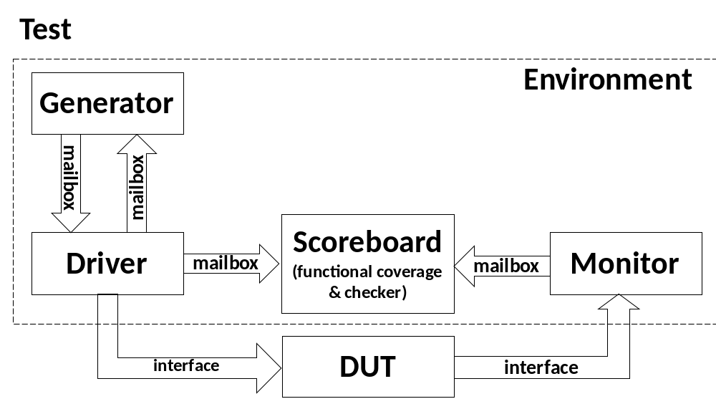
The reason for having a return mailbox from the driver to the generator is for synchronizing the two threads via handshaking so that the generator generates transactions as the driver uses them, and not all at once occupying too much memory.
The test program makes use of the environment class is as follows:
program automatic test(ac_if.test acif);

environment env;
initial begin
$vcdpluson;
env = new(acif);
env.build();
env.run();
env.wrap_up();
end

endprogram

The interface (acif) is passed to the environment for use by the driver and monitor. Inside the driver and monitor classes, the same interface is used and hence defined as a virtual interface, and received as an input argument in their custom constructors (new function).

The environment class is as follows:
class environment;
generator gen;
driver drv;
monitor mon;
scoreboard scb;
mailbox gen2drv, drv2gen, mon2scb, drv2scb;
virtual ac_if.test acif;
extern function new(input virtual ac_if.test acif);
extern virtual function void build();
extern virtual task run();
extern virtual task wrap_up();
endclass : environment

function environment::new(input virtual ac_if.test acif);
this.acif = acif;
endfunction : new

function void environment::build();
gen2drv = new();
drv2gen= new();
mon2scb = new();
drv2scb = new();
gen = new(gen2drv, drv2gen);
drv = new(gen2drv, drv2gen, drv2scb, acif);
scb = new(drv2scb, mon2scb);
mon = new(mon2scb, acif);
endfunction : build

task environment::run();
fork
gen.run();
drv.run();
mon.run();
scb.run();
join_none
endtask : run

task environment::wrap_up();
fork
gen.wrap_up();
drv.wrap_up();
mon.wrap_up();
scb.wrap_up();
join
endtask : wrap_up
A partial code of the generator class is given below. Write the code of the generator’s run task such that it will randomize the transaction (5 points) and send it to the driver via the mailbox (5 points) and waits for a return transaction from the driver before producing the next transaction (5 points). Write the code in the space given below:

class transaction;
rand bit [7:0] in;
bit [15:0] sum;
endclass

class generator;
transaction tr;
mailbox mbx, rtn;
extern function new(mailbox mbx, rtn);
extern virtual task run();
extern virtual task wrap_up();
endclass : generator

function generator::new(mailbox mbx, rtn);
this.mbx=mbx;
this.rtn=rtn;
endfunction : new

task generator::run();
//write the run task here

endtask : run

task generator::wrap_up();
//empty for now
endtask : wrap_up
A partial code of the driver class is given below. Write the code of the driver’s run task such that it will do the following
- Applies reset at the beginning (5 points).
- Self-checks the success of the reset operation (i.e. checking that the sum output from design indeed becomes zero as a result of applying the reset input, and display pass/fail message) (5 points).
- Then, in a loop, obtains a transaction from the generator (5 points), returns it to the generator as an acknowledgment for synchronization (5 points), sends the transaction to the scoreboard (5 points), finally drives the DUT interface with the transaction (5 points), and waits for a clock cycle (5 points).
Write the code in the space given below:
class driver;
virtual ac_if.test acif;
transaction tr;
mailbox mbx, rtn, mbx_scb;
extern function new(mailbox mbx, rtn, mbx_scb, input virtual ac_if.test acif);
extern virtual task run();
extern virtual task wrap_up();
endclass : driver

function driver::new(mailbox mbx, rtn, mbx_scb, input virtual ac_if.test acif);
this.mbx=mbx;
this.rtn=rtn;
this.mbx_scb=mbx_scb;
this.acif = acif;
tr=new();
endfunction : new

task driver::run();
//write the run task here

endtask : run

task driver::wrap_up();
wait (acif.cb.sum == 16'hFFFF);
@acif.cb;
$display("***Sum output saturated to 16'hFFFF; Finishing simulation***");
$finish;
endtask : wrap_up

A partial code of the monitor class is given below. Write the code of the monitor’s run task such that it will first wait for the reset to be applied and removed (5 points). Then, in each clock cycle, it will read the DUT sum output via the interface and store it in the sum element of the transaction (5 points) and send the transaction to the scoreboard via mailbox (5 points).
Write the code in the space given below:

class monitor;
virtual ac_if.test acif;
transaction tr;
mailbox mbx;
extern function new(mailbox mbx, input virtual ac_if.test acif);
extern virtual task run();
extern virtual task wrap_up();
endclass : monitor

function monitor::new(mailbox mbx, input virtual ac_if.test acif);
this.mbx=mbx;
this.acif = acif;
tr=new();
endfunction : new

task monitor::run();
//write the run task here

endtask : run

task monitor::wrap_up();
//empty for now
endtask : wrap_up
A partial code of the scoreboard class is given below. The scoreboard performs functional coverage collection and self-checking the correctness of DUT output results. Write the code of covergroup such that it defines coverage on the 8-bit data inputted to the DUT (5 points) with 16 equally sized bins (i.e. auto bins) (5 points). Write the scoreboard’s run task such that it will get a transaction form the driver (5 points), perform coverage sample on it (5 points), compute expected DUT sum output (5 points), get a transaction from the monitor (5 points), compare the obtained DUT sum output and the expected sum output and display a pass or fail message (5 points).
Write the codes in the spaces given below:

class scoreboard;
int unsigned exp_sum; //variable to hold expected DUT sum output
transaction tr_in, tr_out; //transaction inputted to DUT and outputted by DUT
mailbox mbx_drv, mbx_mon;

covergroup cov;
//write the functional coverage definition here

endgroup

extern function new(mailbox mbx_drv, mbx_mon);
extern virtual task run();
extern virtual task wrap_up();
endclass : scoreboard

function scoreboard::new(mailbox mbx_drv, mbx_mon);
this.mbx_drv=mbx_drv;
this.mbx_mon=mbx_mon;
this.exp_sum = 0;
tr_in=new();
tr_out = new();
cov = new;
endfunction : new

task scoreboard::run();
//write the run task here

endtask : run

task scoreboard::wrap_up();
//empty for now
endtask : wrap_up

You are not allowed to add any more blocks to the testbench or to modify the top level of the testbench, or to add any new classes.

Submit the following:

- This file with missing pieces of code copied in the right places. (100 points, breakdown shown above)
- all your code files. (100 points, breakdown shown above)
- VCS simulation report (the log file or the snapshot of the report on the screen (10 points)
- Waveforms showing the DUT ports (10 points)

